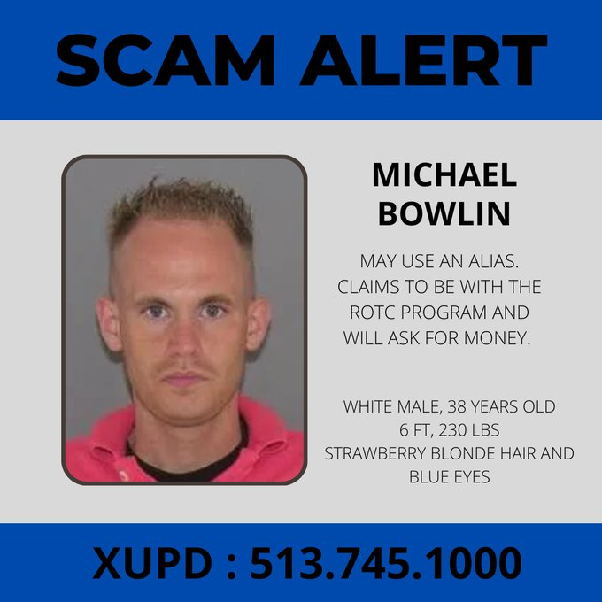
This man has also been in our area, knocking on doors asking for money. He states he is with the Xavier ROTC program and he is not. If he comes to your door, please alert the number listed above. While what he is doing is not illegal, Xavier police would like to be contacted if he comes to your door.

